Queries

Concern No.: 1.
Text/labels (+3V3 and GND) are placed inside IC U4 which would is not a good practice and it would be useless after soldering of IC. Good practice is to place net labels outside the components and close to the respective pin(s).

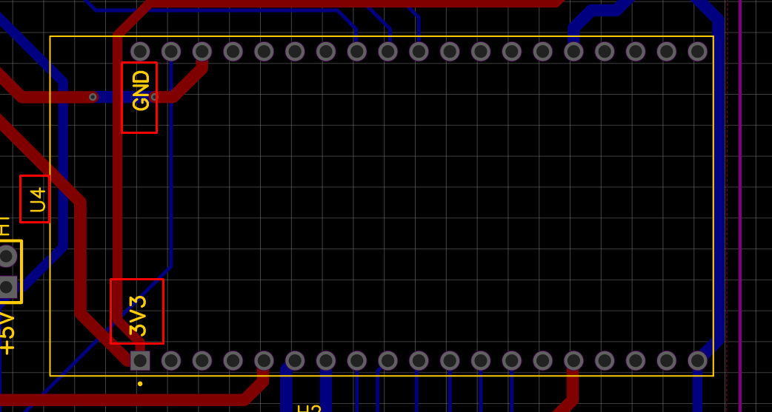

Concern No.: 2.
Following routes/tracks are strictly not recommended. Tracks forming Y, Lambda and T must be avoided.

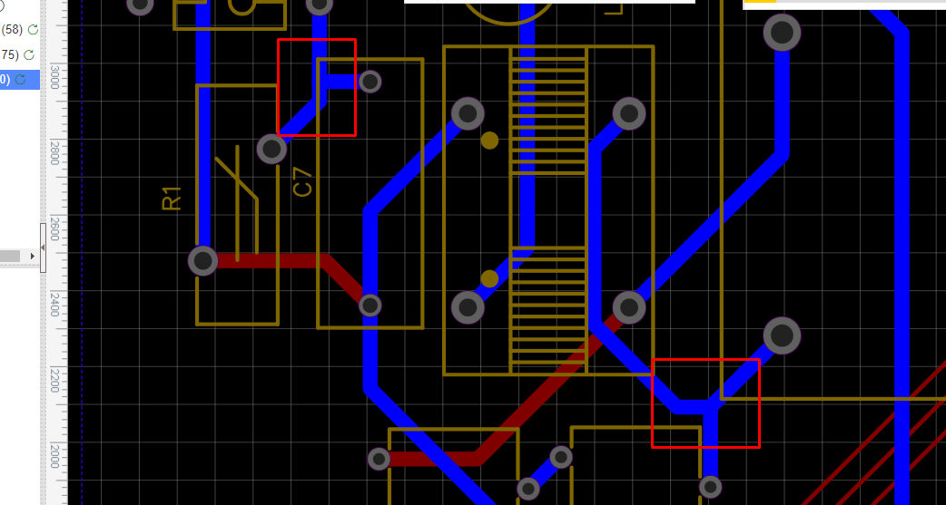
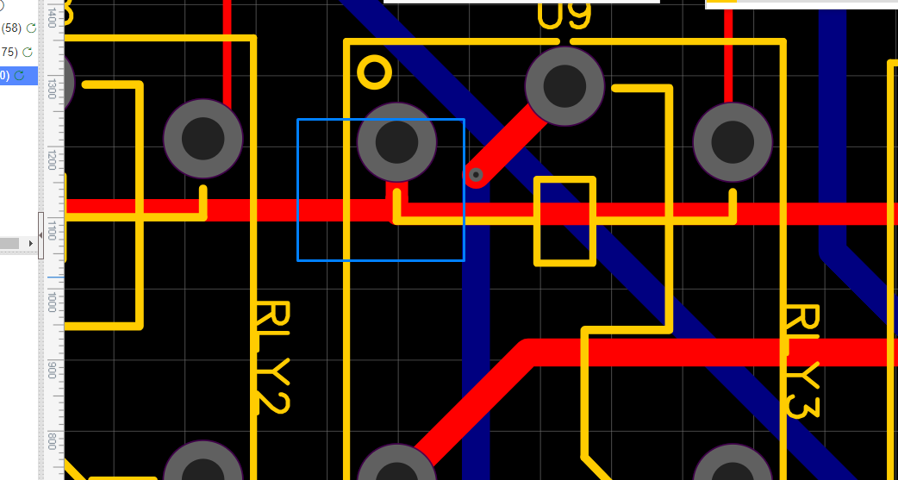

Concern No.: 3.
PCB Design comprises of power modules and it is highly recommended to add separate via’s with each pads of input and output capacitors which are missing with C1, C2, C4 and C5 in our PCB.

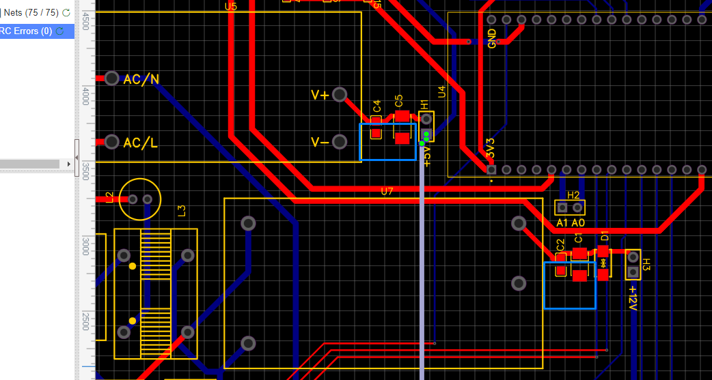

Concern No.: 4.

Designators of Relays placed incorrectly as they are coinciding with their outline on silk layer of PCB.

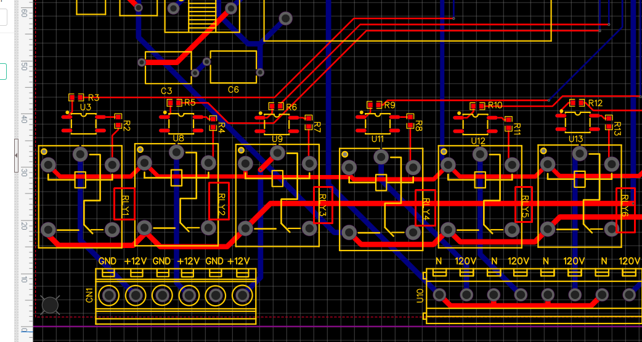

Concern No.: 5.

Line width of designators must not be smaller than 8mil as designators of below 8mil may result in miss-printing and as a result visibility could be an issue.

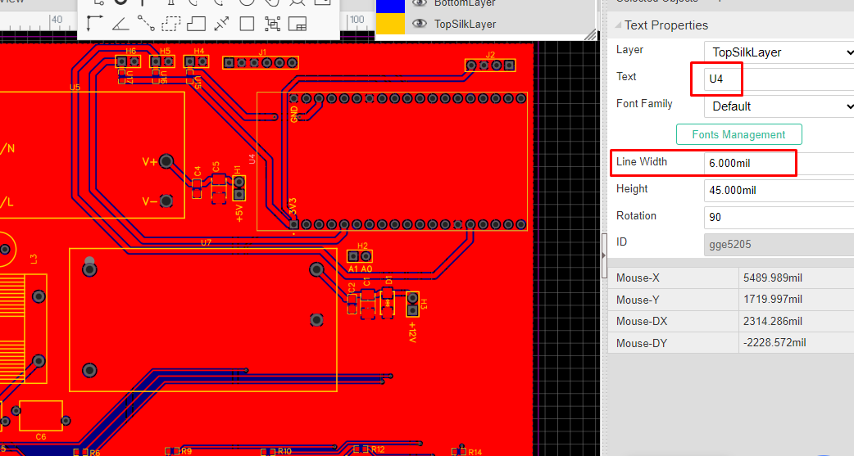

Suggestions:

- PCB Design comprises of power modules that deals with both AC and DC signals. So good practice is to use board cutout in order to separate AC and DC signals.

- It is highly recommended to add High Voltage AC symbol on silk layer close to connector so that user can handle PCB carefully.

- TVS Diodes should be used with input of both converters U5 and U7 for protection against voltage transients.

- Power modules should always be placed faraway from digital IC’s such as ESP32XX etc. In our case it is close to ESP32 (U4).

- Suggestion is to use standard naming convention of designators of components. Few of the designators used in PCB are non-standard i.e. U is used for Fuse and connectors where it should be F and J respectively.

- In two layer PCB design it is suggested to use thick polygon pours/copper/copper zone on power nets for better power handling capability.

